YEAR 11 GENERAL HUMAN BIOLOGY

DO NOT MARK THIS BOOKLET

Multiple Choice 15 Marks

Short Answer 30 Marks

Total 55 Marks

Task 5: Circulatory and Respiratory Systems

Part 1: Multiple Choice (25 marks)

Please circle the correct answer on the multiple choice answer sheet provided

1. Wind pipe is a common name for:

a) Larynx

b) Pharynx

c) Trachea

d) Diaphragm

1. During expiration the:

a) diaphragm lowers

b) ribs move upwards and outwards

c) size of the thoracic cavity increases

d) pressure inside the thoracic cavity increases

1. One function of white blood cells is to

a) assist in the clotting of blood

b) carry haemoglobin

c) engulf/remove bacteria

d) transport carbon dioxide

1. The valves between the chambers of the heart ensures:

a) blood is maintained at a constant pressure

b) blood is pumped at all times

c) blood flows in one direction

d) all chambers of the heart can fill with blood simultaneously

1. Which of the following are involved in pulmonary circulation?
2. Right ventricle, pulmonary trunk, left atrium
3. Superior vena cava, right atrium, right ventricle
4. Left ventricle, aorta, pulmonary trunk
5. Right atrium, right ventricle, left atrium
6. The strong tendinous cords called the chordae tendinae
7. Strengthen the septum
8. Support the pericardium surrounding the heart
9. Prevent the valves from turning inside out
10. Slow down the flow of blood through the heart
11. The liquid part of the blood is called
12. Platelets
13. Plasma
14. Cytoplasm
15. Haemoglobin

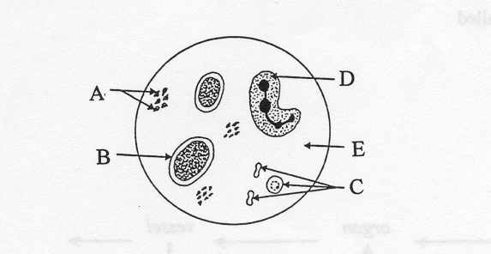

1. In the diagram above of human blood seen through a microscope, which structure is a red blood cell
2. A
3. B
4. C
5. D
6. Which component of the blood is important in blood clotting?
7. A
8. B
9. C
10. All of the above
11. Red blood cells are produced by
12. Yellow bone marrow
13. Red bone marrow
14. Thymus gland
15. Blood
16. Which one of the following statements about the function of blood is not true? Blood
17. Carries hormones from one part of the body to another
18. Transports waste products away from areas of high concentrations
19. Transports nutrients away from areas of high concentrations
20. Provides readily available energy in the form of ATP to the cells
21. The blood vessels found in a mammalian system that are thin enough to allow diffusion to occur across their walls are called
22. veins
23. capillaries
24. arteries
25. alveoli

## The data presented below was recorded in an experiment where a subject breathed in and out of a paper bag and the percentage of carbon dioxide in the air in the bag was recorded. The rate and depth of breathing of the subject was also measured.

|  |  |  |
| --- | --- | --- |
|  | Normal breathing | After rebreathing |
| % of CO2 in bag | 0.4 | 1.52 |
| Depth of breathing | 673 mL | 7.94 mL |
| Rate of breathing | 14/min | 15/min |

## Given the data above the volume of air breathed by the subject in one minute of normal breathing is

## 9422L

## 9422mL

## 40L

## 40mL

## What was the percentage change in the depth of breathing between normal breathing and rebreathing?

## 8.4%

## 84.7%

## 1.1%

## 40.6%

## Exchange of gases in the alveolus of the mammalian lung is by

## Osmosis

## Diffusion

## Capillary force

## Dialysis

## **Section B Short Answer 30 Marks**

Question1

Name vessels

1. A______________________________________

B______________________________________

C______________________________________

D______________________________________

(4 marks)

(b) (i) State which vessel(s) carry oxygenated blood using the letter(s) indicated in the diagram above.

____________________________________________________________________________________________________________________________

(2 mark)

**(c)** The diagram below shows the cross section of an artery and a vein respectively.

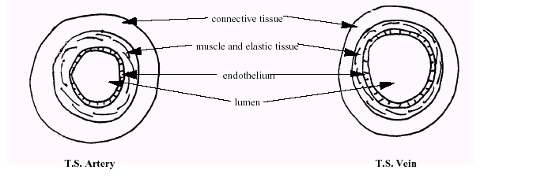(i) What is the role of the elastic tissue that makes up the arteries?

(2 marks)

_______________________________________________________________

_______________________________________________________________

_______________________________________________________________

(ii) Why do we describe an artery and a vein as organs? (2 marks)

_______________________________________________________________

_______________________________________________________________

_______________________________________________________________

(iii) What differences in structure are there between an artery and a vein? (3 marks)

_______________________________________________________________

_______________________________________________________________

_____________________________________________________________________________________________________________________________________________________________________________________________

(iv) Describe the structure of a capillary (2 marks)

_______________________________________________________________

_______________________________________________________________

_______________________________________________________________

_______________________________________________________________

_______________________________________________________________

(v) Consider the effects of a heart attack on the function of the organ above. If the heart attack resulted in damage to the muscular wall of the left ventricle so that the left ventricle was no longer, able to pump the same amount of blood as it did in normal circumstances. What would be the effect on the individual concerned? Explain your answer.

(2 marks)

_________________________________________________________________

_________________________________________________________________

_________________________________________________________________

_________________________________________________________________

Question 2

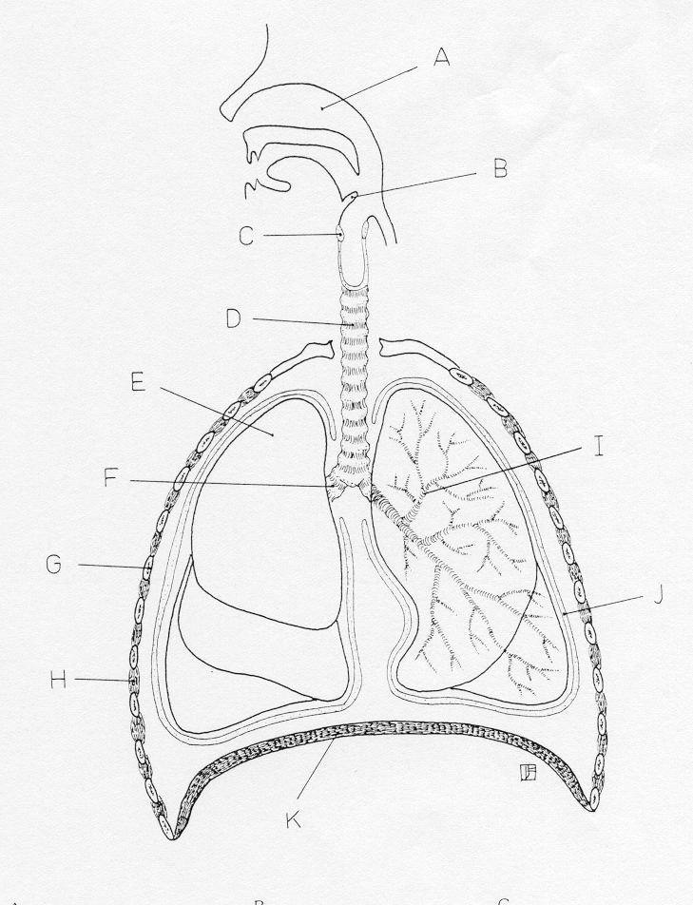

A ______________________ C ___________________

D ______________________ F ___________________

I ______________________ H ___________________

J ______________________ K ___________________

(8 marks)

1. List three features that a respiratory surface has in order to maximise the diffusion of gases.

________________________________________________________________

________________________________________________________________

_________________________________________________________________

_________________________________________________________________

_________________________________________________________________

(3 marks)

1. Describe the bronchioles of an individual having an asthma attack.

(2 marks)

_______________________________________________________________________________________________________________________________________________________________________________________________________________________________________________________________________________________________________________________________________________

**YEAR 11 GENERAL HUMAN BIOLOGY**

Test 2:

Circulatory & Respiratory System

SCORES:

MC: /15

SA: /30

TOTAL: /45

_______ %

**NAME:_____________________________**

**TEACHER:__________________________**

**DATE:______________________________**

**Section A: Multiple choice (15 Marks)**

Answer all questions by circling the most correct answer on the multiple choice answer sheet.

1. a b c d 14. a b c d

2. a b c d 15. a b c d

3. a b c d

4. a b c d

5. a b c d

6. a b c d

7. a b c d

8. a b c d

9. a b c d

10. a b c d

11. a b c d

12. a b c d

13. a b c d